Sea School Stories

Teaching Pack
For
Sully the Seahorse

www.seaschoolstories.co.uk
You are welcome to adapt these resources to make them easier or more challenging, according to your child’s ability.
I can write sentences about what I can see on the front cover of Sully the Seahorse.

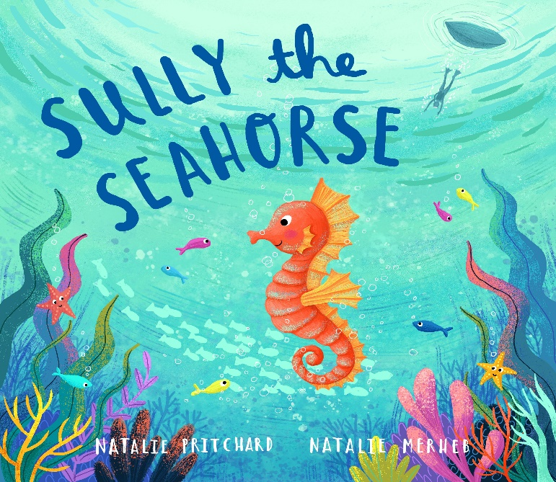

I can use inverted commas / speech bubbles to add to the characters in illustrations

INTRODUCTION: Read the first four pages of the story – up to ‘It was the annual game called Sea School Stars’. Discuss what has happened in the story so far? What is Sea School Stars? A competition? Why do you think Sully was worried about it?

Look at the first two pages where Sully is looking on at the others and feeling sad because he is so small. Show the children that there are no inverted commas on these two pages because none of the creatures are directly speaking.

TALK: Talk with your child about what Sully might be saying at this point to the other creatures. Practice drawing speech bubbles – write in a sentence which Sully might be saying. Think about how he is feeling at this point.

ACTIVITY: Children to use worksheet on next page to write a sentence with inverted commas, which can be added to the story.

I can use inverted commas / speech bubbles to add to the characters in illustrations
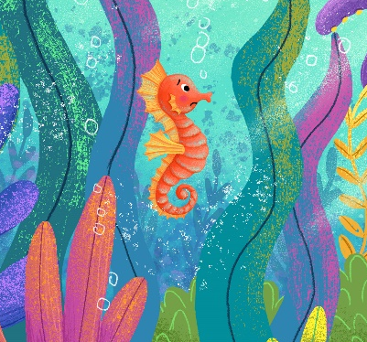

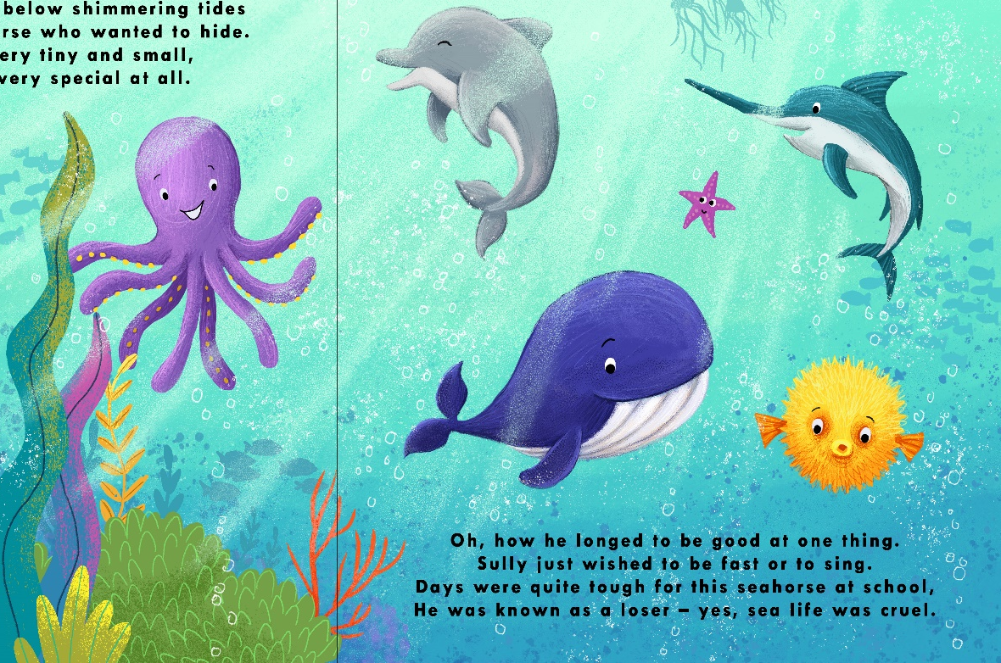

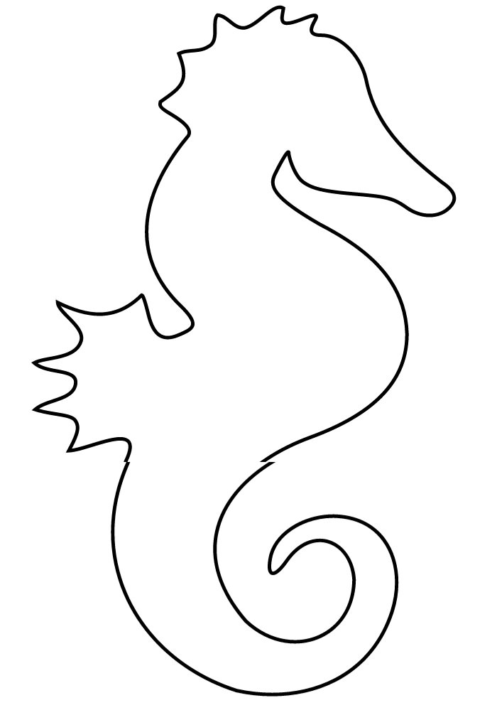

Facts about seahorses

- I can listen and recall facts about seahorses.
- I am using full stops and capital letters.
- I can leave finger spaces between each word.
- I can use conjunctions to extend my sentences.



______________________________________________________________________________________________________________________________________________________________________________
_____________________________
_____________________________
_____________________________

I can empathise with a character’s feelings and write simple sentences about it.

READ ON, UP TO THE ‘FINISH LINE’ PAGE WHERE SULLY COMES LAST (P10).

TALK: How is Sully feeling now? If they just respond with sad, try to encourage your child to think of some more interesting words for sad: unhappy, crushed, glum, heartbroken.
Ask your child to talk about a time where they have felt sad because they didn’t win or weren’t very good at something.

How could Sully make himself feel better? Should he give up or keep trying? It is ok to feel sad if you don’t win, but Sully should try and understand that he can’t be good at everything and it’s ok to lose sometimes. It is part of learning and getting better!

MAIN ACTIVITY: Children to write a letter to Sully to cheer him up because he is feeling so sad about losing. Remind your child about using capital letters, finger spaces and full stops.

Use template letter below and encourage children to finish the sentences.

Can you label your seahorse picture using some of your facts?

Dear Sully,
Explain why you are writing the letter:

I am writing to you because_______________________________________________

__________________________________________________________________________

__________________________________________________________________________
Tell Sully if you understand how he feels. Have you ever lost at something?

Firstly, I understand because _____________________________________________

__________________________________________________________________________

__________________________________________________________________________

Give Sully some advice on what he should do if he loses again.

Next time Sully, you should_________________________________________________

___________________________________________________________________________

___________________________________________________________________________

Summary: Tell Sully you think he’s special and fabulous in his own way!

I think you are ____________________________________________________________

___________________________________________________________________________

Yours Sincerely,

To identify rhyming patterns and to start to write my own rhyming poems
TODAY WE ARE GOING TO READ SOME MORE OF THE STORY BUT ALSO TODAY WE ARE GOING TO LISTEN REALLY CAREFULLY TO TRY TO FIND ANY RHYMING WORDS IN THE STORY.
READ FROM FINISH LINE PAGE TO P16 ‘HOPING TO GRAPPLE A CATCH OF THE DAY’.
DISCUSS THE STORY AND THEN SAY WE ARE GOING TO LOOK IN MORE DETAIL AT THE RHYMING WORDS AT THE END OF EACH LINE.

TALK: Re-read that part of the story to the children. Using rough paper or whiteboards and pens, children to write down all the rhyming words they can hear. TIP: The endings of the last words don’t ALWAYS have to be spelt the same, they must sound the same e.g: cloud – crowd, prey – day, whales – tails.

How many rhyming words did you spot? The last word in this part of the story is day. What else rhymes with day? Let’s write it as a list.

MAIN ACTIVITY: Cut each line of the poem “Sea School Stories Shuffle Poem’ into strips for your child. They should arrange the poem into rhyming couplets, identifying the rhyming word.

Highlight the rhyming couplets using different colours so it’s easier for pupils to identify them.
Can you write your own two lines for the poem using a different sea creature and a rhyming couplet at the end of each sentence?

Go through the original poem together and check that your child has identified the rhyming couplets.

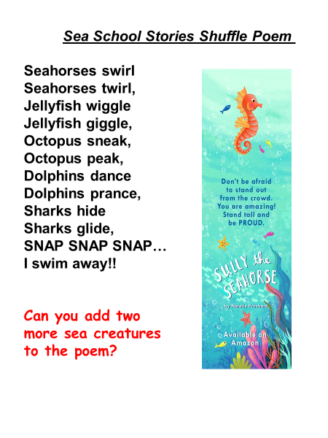

I can sequence the story of Sully the Seahorse using a picture storyboard
FINISH THE STORY. ASK YOUR CHILD WHETHER IT HAD A HAPPY ENDING OR SAD ENDING.
TALK ABOUT THE MORAL OF THE TALE AND WHAT SULLY HAD LEARNT ABOUT HIMSELF ALONG THE WAY.
EXPLAIN TO YOUR CHILD THAT STORIES HAVE A BEGINNING, MIDDLE AND AN END. THERE IS USUALLY A PROBLEM IN THE STORY AND AT THE END THE PROBLEM IS SOLVED.
Talk: What problem did Sully have in the story? How was the problem solved at the end? How did the story come to have a happy ending?

Can you think of the problems in any other well-known story or fairy-tale? Jack and the Beanstalk? Little Red Riding Hood? Show your child the storyboard template and tell them we are going to re-write the story of Sully the Seahorse. Explain that it often helps to create a storyboard, to help you remember all the points in a story and to make sure the structure is correct. Go through the beginning, middle and end of the story with your child so they are clear. Model how to use the storyboard template.

MAIN ACTIVITY: Explain to your child that they need to draw the story of Sully the Seahorse in order, onto their storyboard template. There are six on the template but more or less could be used, depending on the ability of your child.
Cut out the numbered storyboard template (or they can cut their own). Stick them onto a piece of lined A4 paper, in number order. Children to write a sentence or to next to each drawing. E.g box 1 could be a drawing of Sully looking sad getting ready for the race and their sentences for that box could be: Once upon a time there was a seahorse called Sully. He felt sad because he was small and wished he could swim fast like the whales.
This lesson will probably spread over at least two hours.

Use less boxes if your child is younger, so they can write a briefer story. Help them to write their sentences.

Read your child’s story aloud and praise them for their work. Encourage them to spot the beginning, middle and end of the story, as well as the problem.

2
1

3
4

6
5

I can use adjectives to describe the character of Sully the Seahorse

TODAY WE ARE GOING TO WRITE A DESCRIPTION OF SULLY USING ADJECTIVES.
ASK YOUR CHILD: WHAT IS AN ADJECTIVE?

Can you say a sentence about Sully to each other and get your child to guess which word is the adjective?

Tell your child that we can use adjectives to describe what someone looks like and to describe how someone feels. For example – we could say Sully has a long and curly tail. Ask your child which words are adjectives? Yes, it’s long and curly – because those words are describing the tail (noun). Also, we can say at the end of the story, Sully felt really proud because he had discovered his special talent. The adjective is proud because it describes how Sully is feeling.

MAIN ACTIVITY: We are going to write a character description of Sully using adjectives, in full sentences. Your child can use the work sheet below, or they can write directly onto a sheet of paper, depending on age group and ability.
An adjective bank has been provided on the worksheet but explain to your child that not all of those adjectives are the right ones to use for Sully. They need to choose the ones that best describe Sully and use them in full sentences.

In the space provided on the worksheet, draw a picture of Sully, based on the adjectives they have used.

Can you use two adjectives before you noun? For e.g: Long, curly tail; long, pointed snout.

What have we learnt today about adjectives? Why are they really useful when we are writing stories?

I can use adjectives to describe the character of Sully the Seahorse

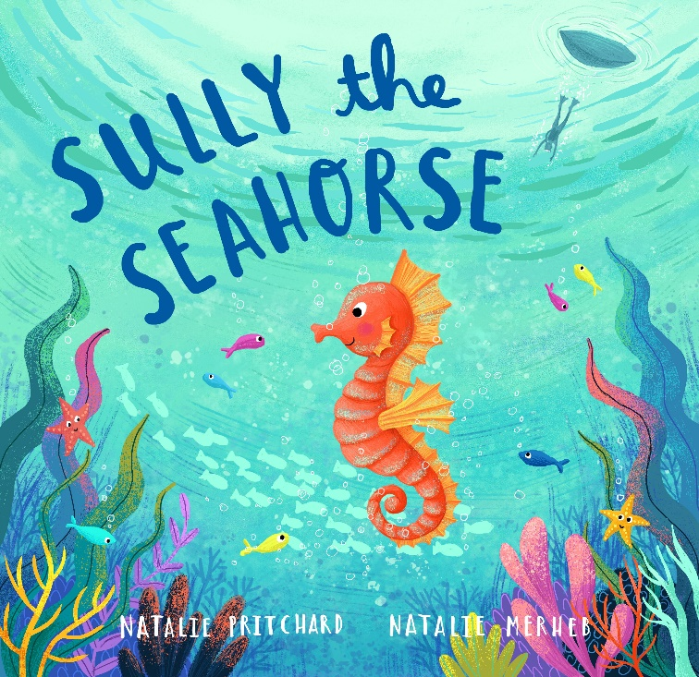
ADJECTIVE BANK

long cute nervous
orange fast beautiful
small slow cute
patient tiny angry
determined brave jealous
clever smart colourful
worried sad pretty

I can make comparisons to my own experiences (write about my own special talents)
Like Sully discovered his special talent of changing colour, do you have a special talent which makes you unique? Explain to your child that it doesn’t have to be something at school such as spellings or handwriting (although it can be!), their special talent might be singing, hopping, baking or drawing etc.
ALL OF US ALSO HAVE SOMETHING WE WISH WERE BETTER AT IT. GIVE AN EXAMPLE OF WHAT YOU WISH YOU WERE BETTER AT….E.G SWIMMING.
It’s important that we recognise the qualities of other people too. Tell your child what you think is special about them. Do they play nicely with their brother or sister? Or help you with the cooking? Or give good hugs?
MAIN ACTIVITY:
We are going to write about what our special talent is. Use the fish lined template below for your child to describe their special talent.
After this, your child should then also write about something they are not so good at, and what they are going to do to get better at it. E.g – I am not very good at handwriting, but I am going to practice as much as I can with my Mummy at home so that I improve and become as good as I can be. Encourage your child to use the words practice, try again and don’t give up!

Can you write a mystery compliment about someone in your house and leave it somewhere in the house for them to read? It will make their day! 😊

What have we learnt today about being unique? What should you do if you lose at something or you make a mistake? Is it ok to make mistakes?

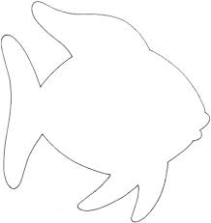

My goal – I want to get better at…

___________________________________________________________________________________________________________________________________________________________________________________________________________

I can write my own story based on a sea creature.
TODAY WE ARE GOING TO BE AUTHORS AND WRITE OUR OWN STORY ABOUT A SEA CREATURE WHICH COMES ACROSS A PROBLEM.

WHAT ARE THE SPECIAL FEATURES OF A STORY? REMEMBER YOUR STORY NEEDS A BEGINNING MIDDLE AND END, WITH A PROBLEM WHICH GETS SORTED OUT. REMIND YOUR CHILD TO USE CORRECT PUNCTUATION INCLUDING CAPITAL LETTERS, FINGER SPACES AND FULL STOPS.

Talk to your child about what sea creature they are going to write about, what its special talent is and what problem the creature must overcome. Maybe it’s a dolphin who’s lost her singing voice, or a baby turtle that’s lost his Mummy?

Tell your child they are going to create a story plan to help them to think of more detail for their stories. Use the story plan template below for your child to create the plan for their stories.

MAIN ACTIVITY: Your child to complete their story plans and encourage your child to really take their time with the story – using their plans to help them add more detail.

Consider using story stones, or props to help your child think of ideas for their story. Check work to make sure they have included all correct punctuation.

Can you use some exclamation marks and inverted commas in your story, where appropriate?

What have we learnt about story writing? Encourage your child to read their story to you out loud and praise them for their fantastic work!

Story planning
Title

Character


Beginning

Middle What problem happens?

Setting
Ending How does it get sorted out?


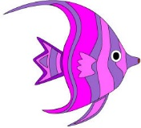
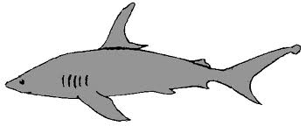

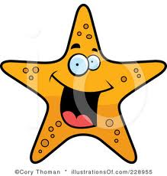
I can count the sea creatures and create a tally chart
Animal
Total
Tally
There are 8 octopuses. Count the sea creatures.
Are there more or less? Tick the right box.
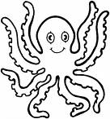
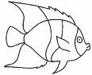 | more
 | less
 | more
 | less
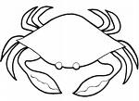 | more
 | less
 | more
 | less

Read and draw the picture.

Shark | Crab
Eel | Starfish

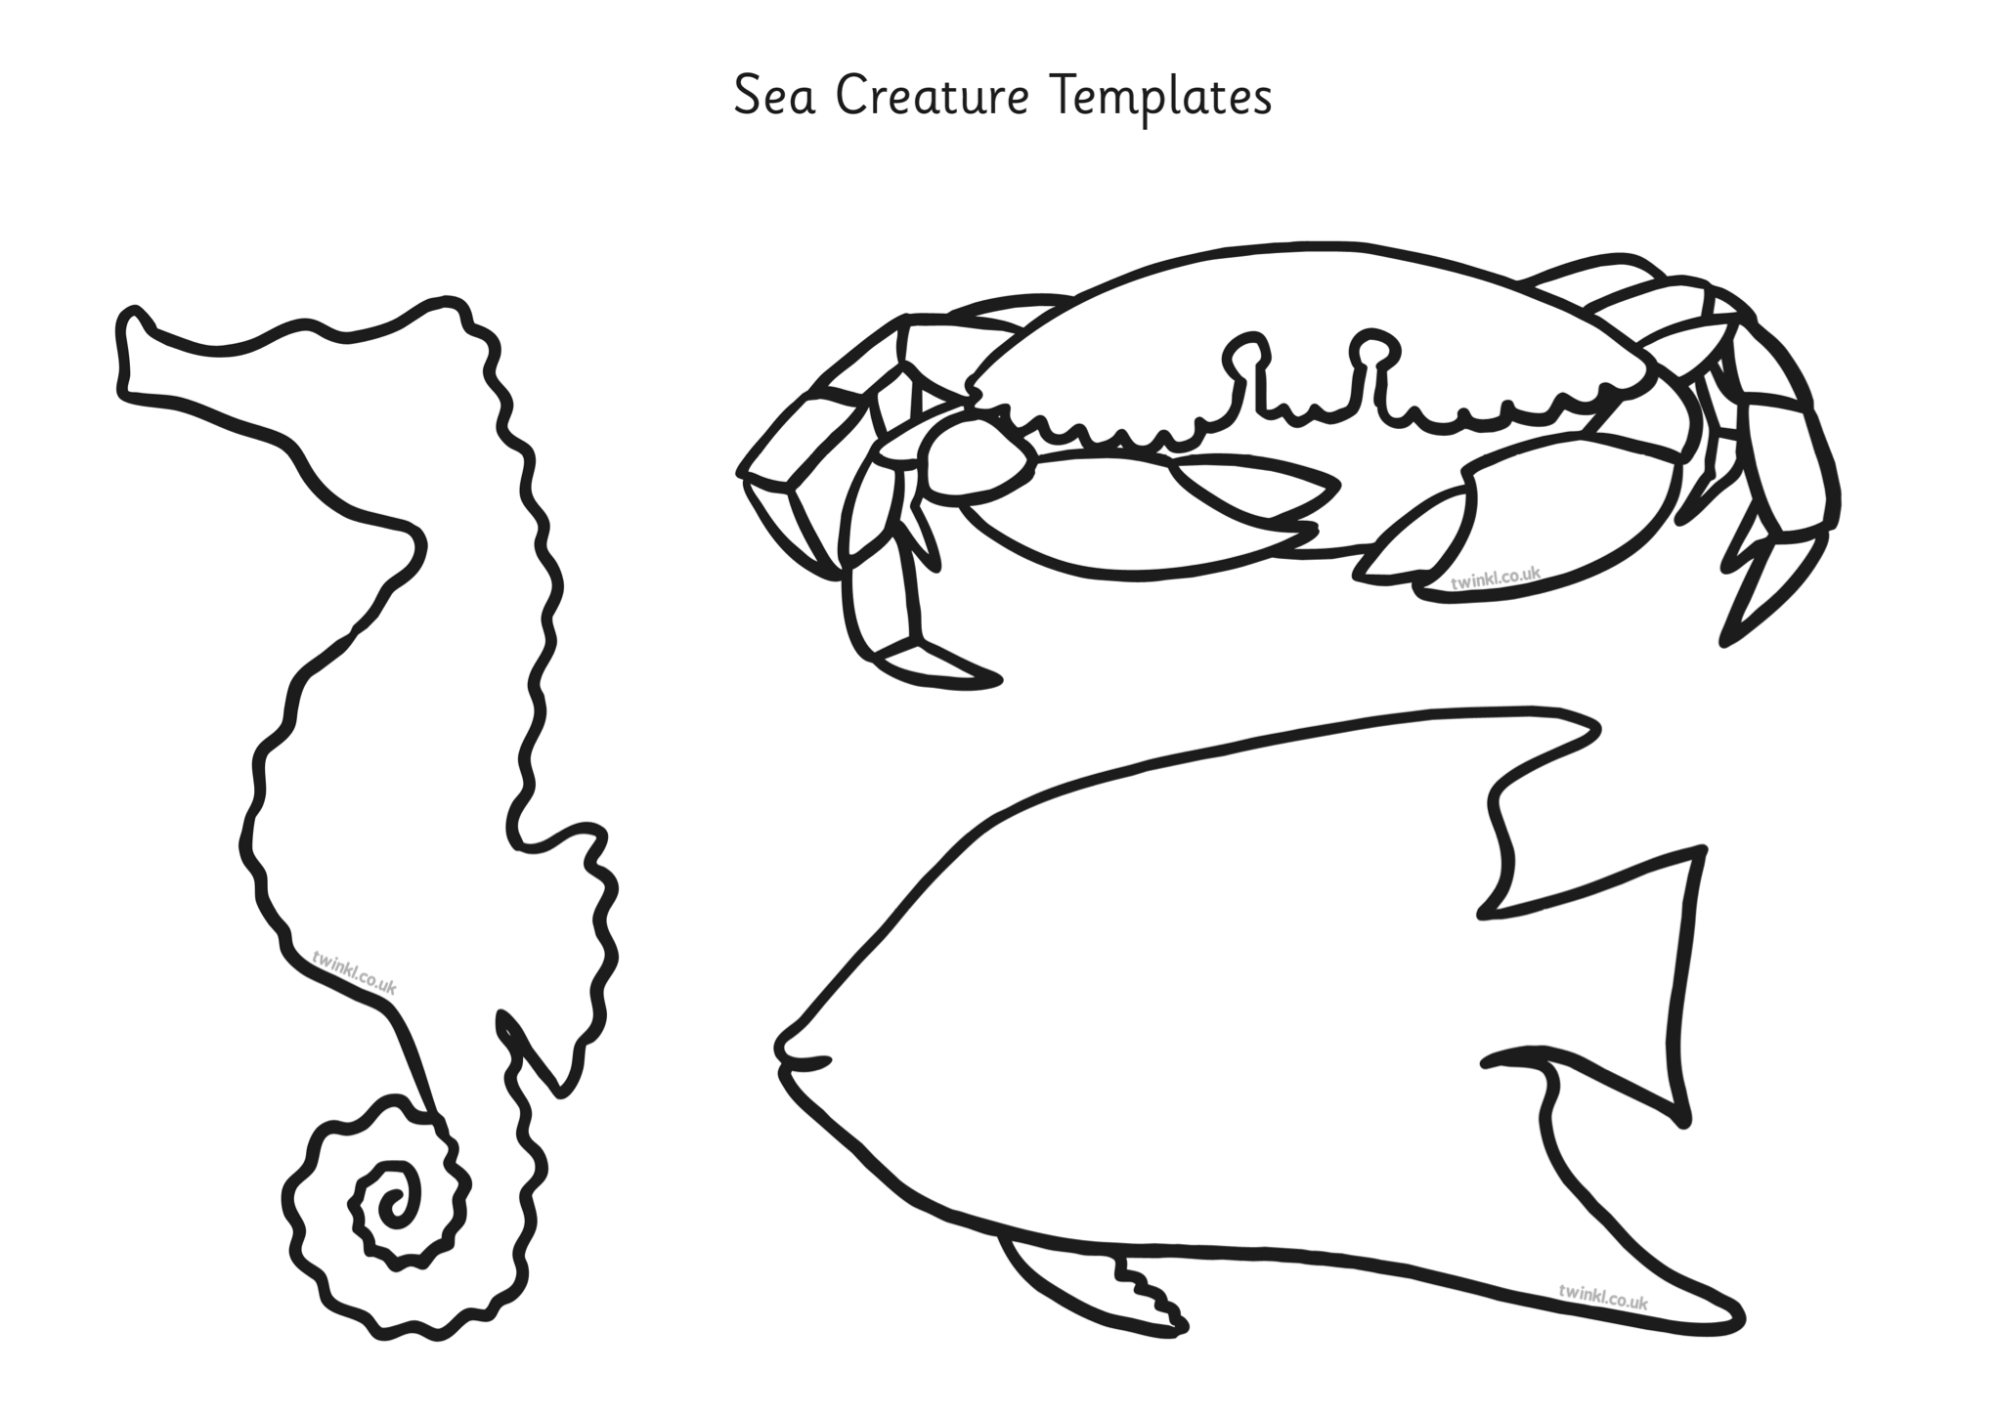
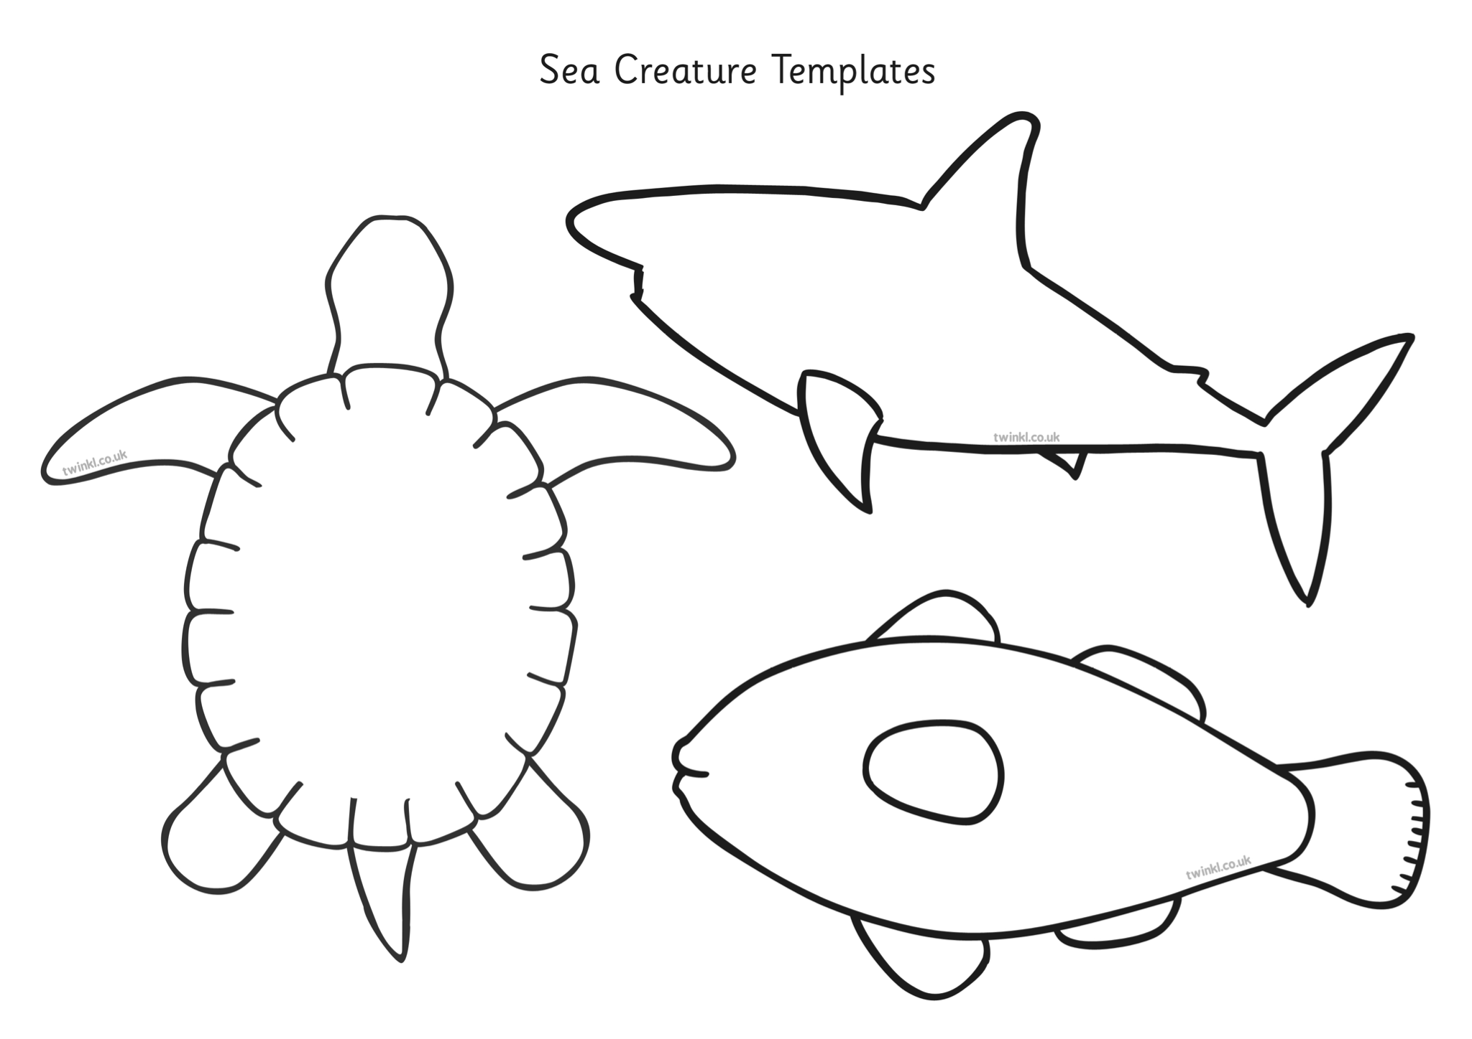
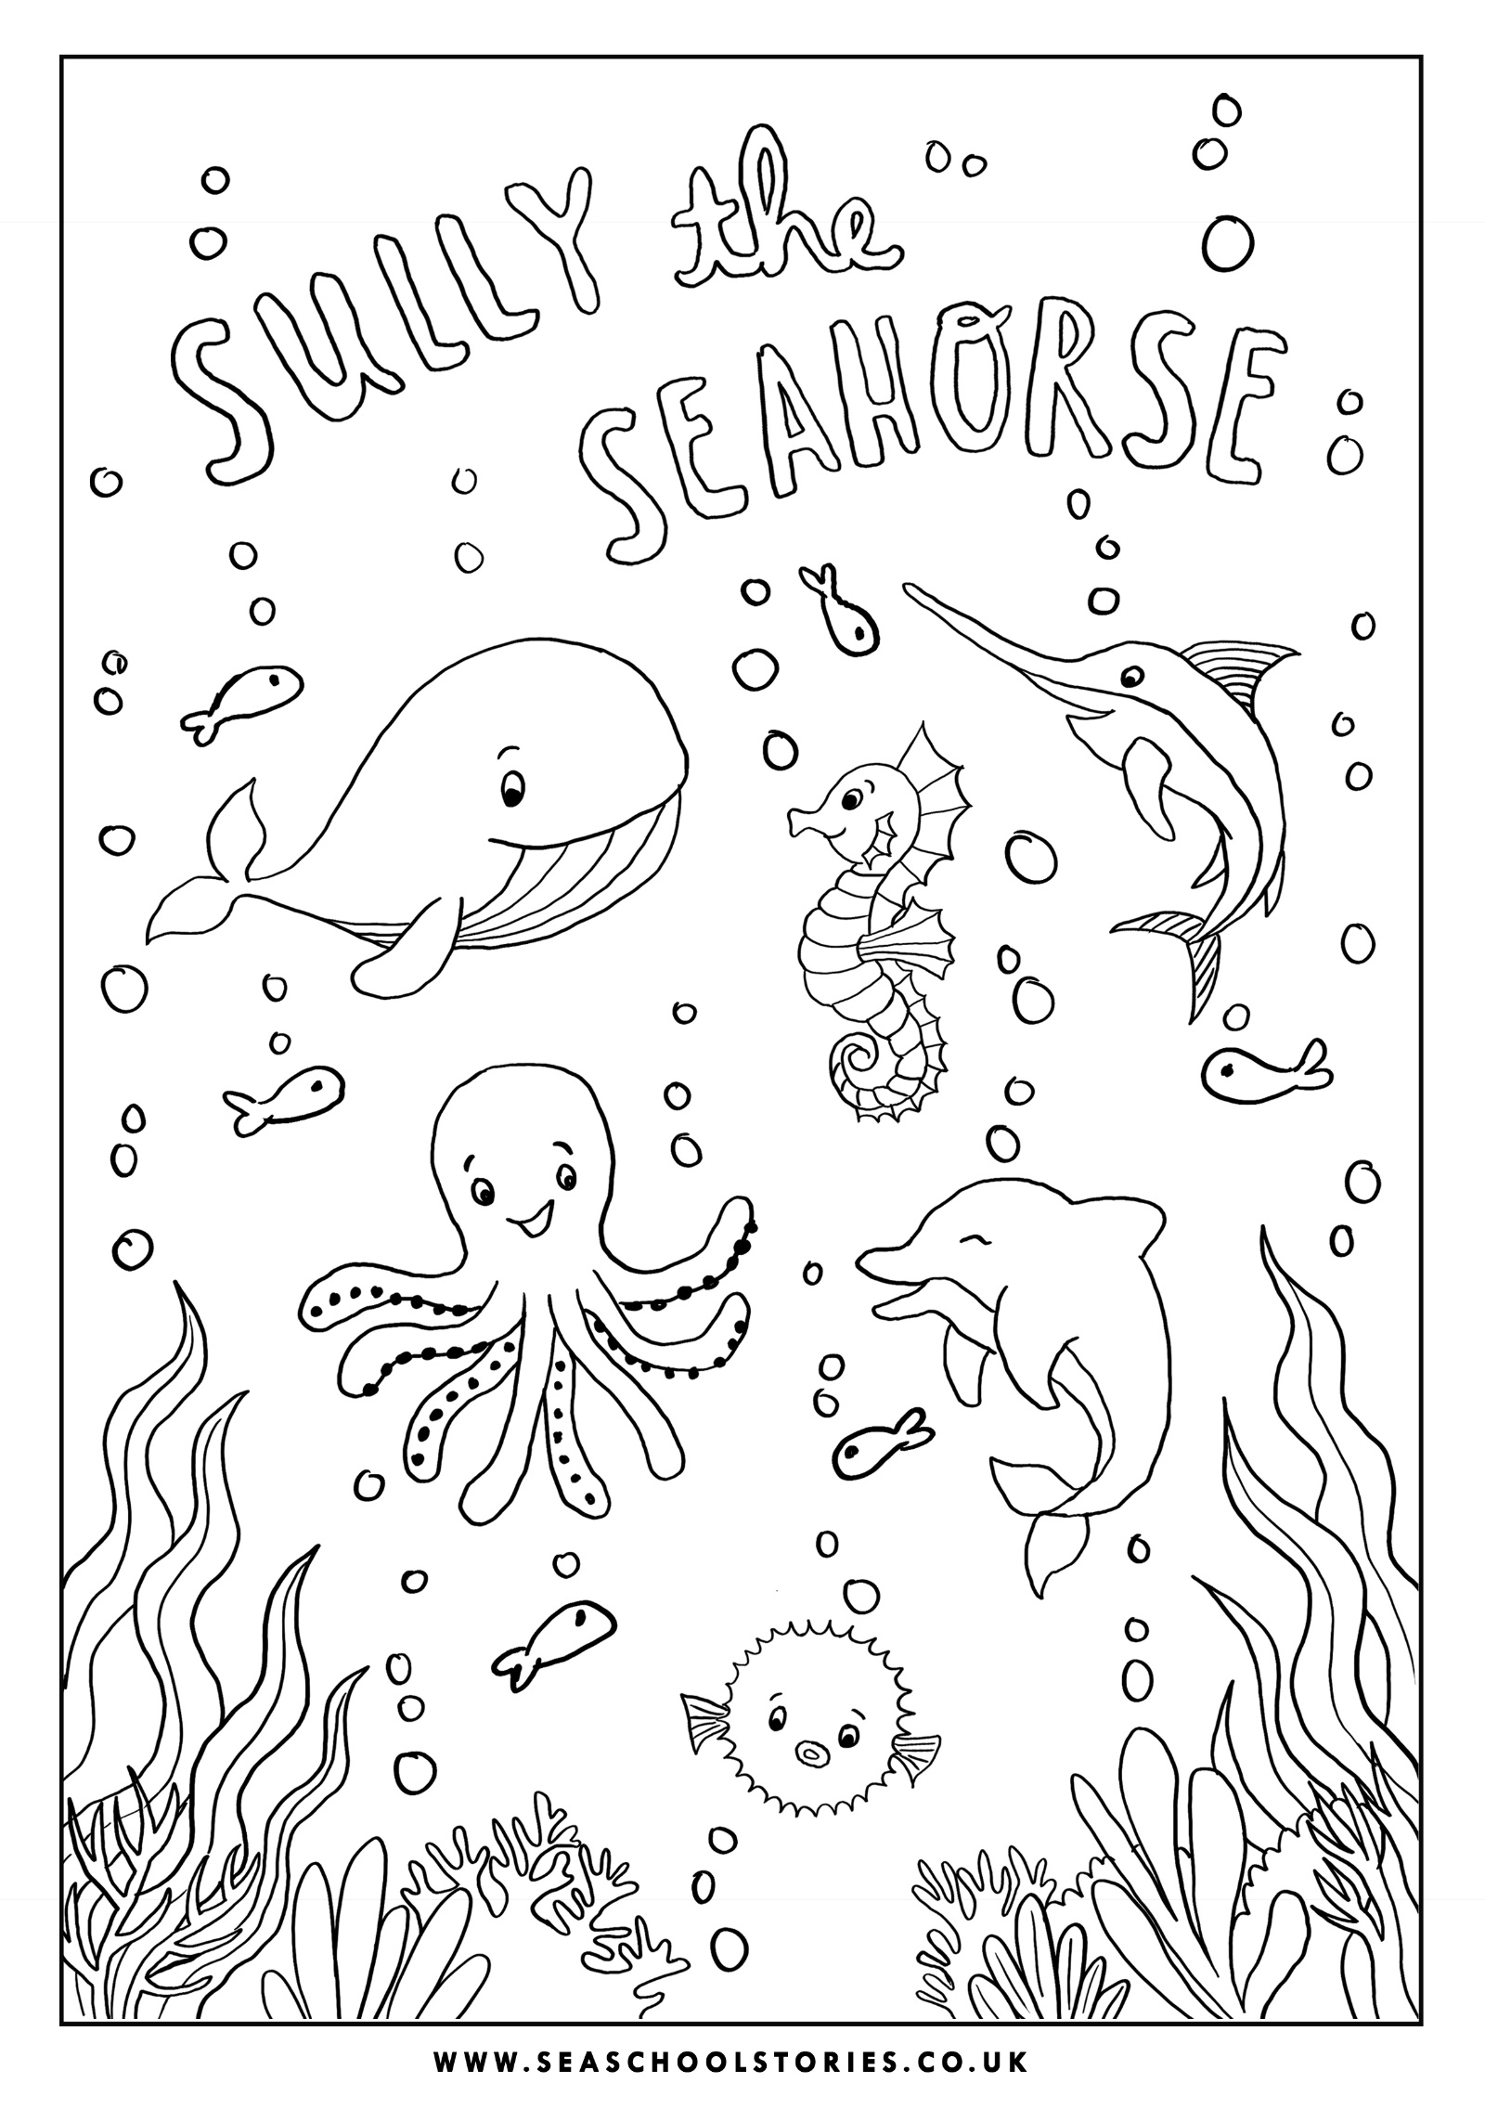
Sea Creature Craft Ideas
