Sea School Stories
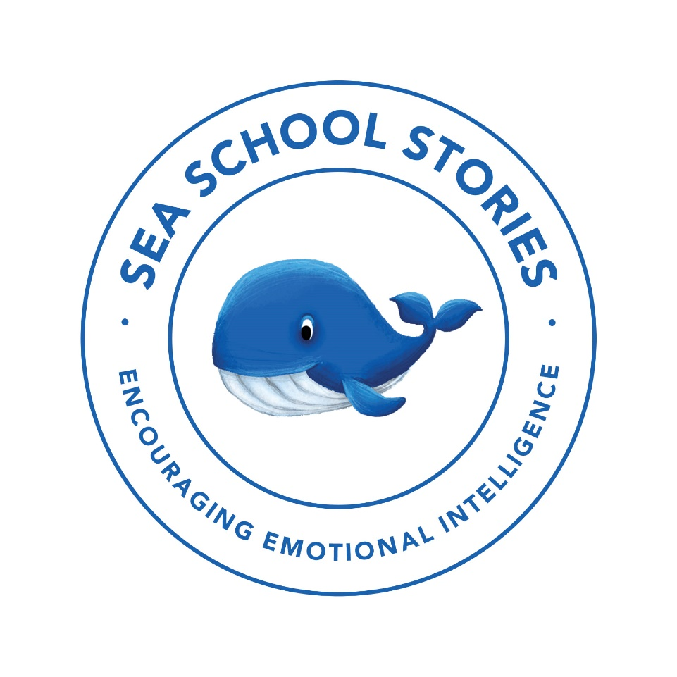
Teaching Pack
For
Monty the Manatee

www.seaschoolstories.co.uk
You are welcome to adapt these resources to make them easier or more challenging, according to your child’s ability.
Introduction:
Introduce your child to the front cover of ‘Monty the Manatee’. What type of animal is a manatee? Google some real images of a manatee and look at the picture on the front cover. What do they think of this animal? What does it look like? What words would they use to describe it? You could create a spider diagram. Does the animal look cute like a kitten? Dangerous like a tiger? Beautiful like a unicorn?

Explain to your child that before you read the book, you are going to research on the internet all about manatees (there is also a fact page you can use at the back of the book).

Your child can use the information gathered to write facts all about manatees, on the worksheet provided.

Remind your child to use correct punctuation including full stops and capital letters. Extend their sentences with conjunctions including ‘and’ and ‘because’.

Older children can write a more detailed information piece, on A4 lined paper, rather than use the worksheet.

Facts about Manatees
- I can listen and recall facts about manatees.
- I am using full stops and capital letters.
- I can leave finger spaces between each word.
- I can use conjunctions to extend my sentences.

______________________________________________________________________________________________________________________________________________________________________________

I can write sentences about what I can see on the front cover of Monty the Manatee

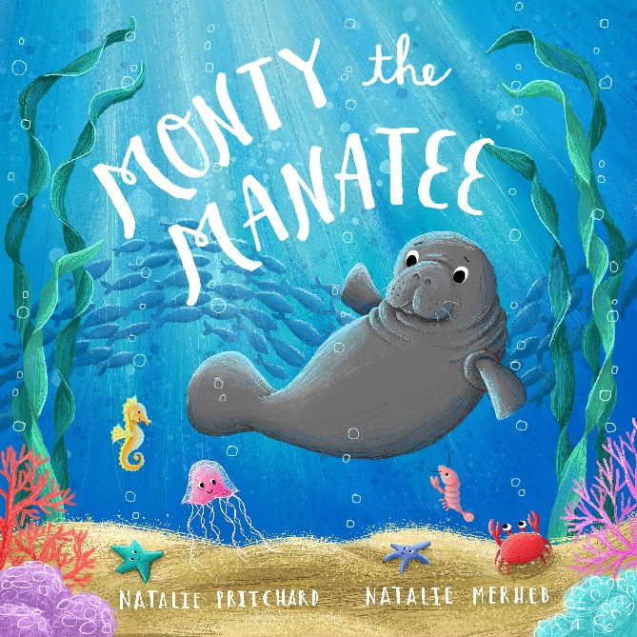

I can empathise with a character’s feelings and write simple sentences about it.

READ TO THE PAGE WHERE THE JELLYFISH ARE MEAN TO MONTY AND SAY ‘LEAVE US ALONE THIS IS A PRIVATE CHAT, SHUSH!’

How would this make Monty feel? If they just respond with sad, try to encourage your child to think of some more interesting words for sad: unhappy, crushed, glum, heartbroken.
Ask your child to talk about a time where they felt sad because someone wasn’t very nice to them or left them out of a game.

MAIN ACTIVITY: Children to write a letter to the jellyfish, to try to persuade them not to be mean to Monty and to include him in their games. They can also tell the jellyfish in the letter, exactly how to be nice and a good friend. E.g – let everyone join in your games, share your toys.

Use template letter below and encourage children to finish the sentences.

Dear Jellyfish,
Explain why you are writing the letter:

I am writing to you because_______________________________________________

__________________________________________________________________________

__________________________________________________________________________
Tell the Jellyfish what they have done wrong and how it hurt Monty’s feelings

Firstly, __________________________________________________________________

__________________________________________________________________________

__________________________________________________________________________

Give the Jellyfish some advice on how to be a good friend

Next time Jellyfish,________________________________________________________

___________________________________________________________________________

___________________________________________________________________________

Summary: tell the Jellyfish that they should say sorry to Monty

I think ____________________________________________________________________

___________________________________________________________________________

Yours Sincerely,

To identify rhyming patterns and to start to write my own rhyming poems
TODAY WE ARE GOING TO READ SOME MORE OF THE STORY BUT ALSO TODAY WE ARE GOING TO LISTEN REALLY CAREFULLY TO TRY TO FIND ANY RHYMING WORDS IN THE STORY.
READ UP TO THE PAGE WHERE MONTY IS SWIMMING BETWEEN THE SCHOOL OF FISH
DISCUSS THE STORY AND THEN SAY WE ARE GOING TO LOOK IN MORE DETAIL AT THE RHYMING WORDS AT THE END OF EACH LINE.

Re-read the page where it starts ‘Who wants to be mates with a manatee?’. Using rough paper or whiteboards and pens, children to write down all the rhyming words they can hear. TIP: The endings of the last words don’t ALWAYS have to be spelt the same, they must sound the same e.g: cloud – crowd, prey – day, whales – tails.

How many rhyming words did you spot? The last word in this part of the story is mine. What else rhymes with mine? Write a list of rhyming words together.

MAIN ACTIVITY: Cut each line of the poem “Sea School Stories Shuffle Poem’ into strips for your child. They should arrange the poem into rhyming couplets, identifying the rhyming word.

Highlight the rhyming couplets using different colours so it’s easier for pupils to identify them.
Can you write your own two lines for the poem using a different sea creature and a rhyming couplet at the end of each sentence?

Go through the original poem together and check that your child has identified the rhyming couplets.

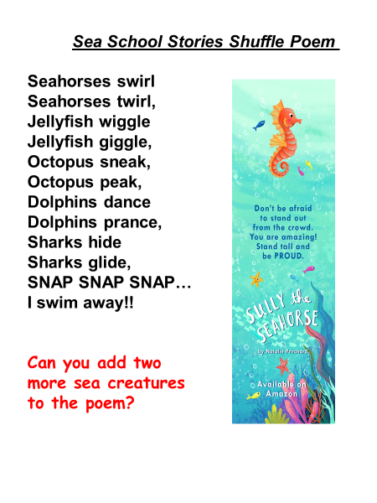
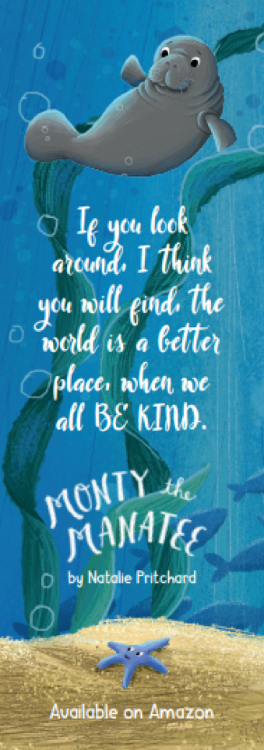

I can sequence the story of Monty the Manatee using a picture storyboard
FINISH THE STORY. ASK YOUR CHILD WHETHER IT HAD A HAPPY ENDING OR SAD ENDING.
TALK ABOUT THE MORAL OF THE TALE AND WHAT THEY HAVE LEARNT FROM THE STORY (BE KIND, DON’T JUDGE PEOPLE BY WHAT THEY LOOK LIKE ETC)
EXPLAIN TO YOUR CHILD THAT STORIES HAVE A BEGINNING, MIDDLE AND AN END. THERE IS USUALLY A PROBLEM IN THE STORY AND AT THE END THE PROBLEM IS SOLVED.
Talk: What problem did Monty have in the story? How was the problem solved at the end? How did the story come to have a happy ending?

Can you think of the problems in any other well-known story or fairy-tale? Jack and the Beanstalk? Little Red Riding Hood? Show your child the storyboard template and tell them we are going to re-write the story of Monty the Manatee. Explain that it often helps to create a storyboard, to help you remember all the points in a story and to make sure the structure is correct. Go through the beginning, middle and end of the story with your child so they are clear. Model how to use the storyboard template.

MAIN ACTIVITY: Explain to your child that they need to draw the story of Monty the Manatee in order, onto their storyboard template. There are six on the template but more or less could be used, depending on the ability of your child.
Cut out the numbered storyboard template (or they can cut their own). Stick them onto a piece of lined A4 paper, in number order. Children to write a sentence next to each drawing. E.g box 1 could be a drawing of Monty and his Mummy waving goodbye to each other at the school gates. They could write underneath: Once upon a time there was a manatee called Monty. He was a little bit worried because it was his first day at Sea School.
This lesson will probably spread over at least two hours.

Use less boxes if your child is younger, so they can write a briefer story. Help them to write their sentences.

Read your child’s story aloud and praise them for their work. Encourage them to spot the beginning, middle and end of the story, as well as the problem.

2
1

3
4

6
5

I can use adjectives to describe the character of Monty the Manatee

TODAY WE ARE GOING TO WRITE A DESCRIPTION OF MONTY USING ADJECTIVES.
ASK YOUR CHILD: WHAT IS AN ADJECTIVE?

Can you say a sentence about Monty to each other and get your child to guess which word is the adjective?

Tell your child that we can use adjectives to describe what someone looks like and to describe how someone feels. For example – we could say Sully has a long and curly tail. Ask your child which words are adjectives? Yes, it’s long and curly – because those words are describing the tail (noun). Also, we can say at the end of the story, Monty felt really happy because all the sea creatures wanted to be his friend. The adjective is happy because it describes how Monty is feeling.

MAIN ACTIVITY: We are going to write a character description of Monty using adjectives, in full sentences. Your child can use the work sheet below, or they can write directly onto a sheet of paper, depending on age group and ability.
An adjective bank has been provided on the worksheet but explain to your child that not all of those adjectives are the right ones to use for Monty. They need to choose the ones that best describe Monty and use them in full sentences.

In the space provided on the worksheet, draw a picture of Monty, based on the adjectives they have used.

Can you use two adjectives before you noun? For e.g: Big, wide flippers.

What have we learnt today about adjectives? Why are they useful when we are writing stories?

I can use adjectives to describe the character of Monty the Manatee

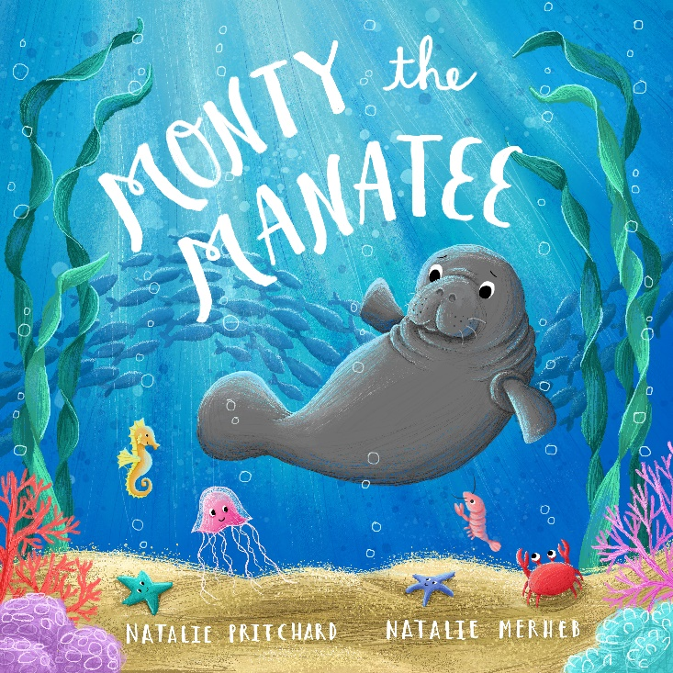
ADJECTIVE BANK

big cute nervous
grey fast beautiful
small slow cute
patient tiny angry
determined brave jealous
clever smart colourful
worried sad kind

I can make comparisons to my own experiences
In this session we are going to think about the difference between what someone looks like and what they are like on the inside. Would you like to be friends with a manatee? With someone who doesn’t look like you? Does it matter what someone looks like?
Talk to your child about what qualities makes a good friend. They will probably mention traits such as, being kind, helpful, good at football, a good listener, laughs at my jokes, likes the colour blue. Does it matter what colour hair your friend has? What clothes they wear? If they are tall or short? Of course not!

What is bullying? What can you do if you see someone being mean to someone else?

MAIN ACTIVITY: Create a poster in the shape of a heart, all about being a good friend. What do you look for in a friend? They can then add pictures. Heart template is on the next page.

What have we learnt today about how to be a good friend?

“If you look around I think you will find, the world is a better place when we all BE KIND.”
MONTY THE MANATEE

Talk about the characteristics of being a good friend
In this session we are going to think about how we can be kind to someone. Give your child an example situation. They can then explain how they would respond with kindness. Scenarios could include:
- a child falls over, what would you do? - you see someone playing alone, what would you do?
- you see someone being mean to another child, what would you do?
- another child really wants to play with the toy you have, what would you do?

How can we be kind to our parents and other adults such as teachers and dinner ladies? (opening doors, helping with the chores etc). What about showing kindness to people who are not as fortunate as ourselves? (Talk about giving old toys to local hospital, fundraising etc.)

MAIN ACTIVITY: Have two hoops on the table. Decide which hoop will represent how to be a good friend and which hoop represents not being a good friend. Some ideas may be in the middle and will need discussing. Cut the ideas up and ask your child to sort them. As an extension, ask the children to add their own ideas for each hoop.

Think about the activity you have just done. Which ideas were obvious? Were any statements a bit trickier to sort? Why?

A good friend | Not a good friend
Shares their toys and games. | Says hello when they see you.
Teases you and calls you names. | Takes your things.
Has fun with you. | Always tells the truth.
Smiles at you. | Allows you to play their games.
Pushes you. | Listens when you talk to them.
Helps you. | Helps when someone else is mean.
Joins in when people laugh at you. | Snatches toys away from you.
Cuddles you all the time. | Always plays with you.
Only plays with you and no one else. | Tells you what games to play.

Send a kindness card to someone you love
Read the end message in ‘Monty the Manatee’. Is it good to be kind? How can it make the world a better place if we are all kind?
Explain to your child that today you’re going to help spread a little kindness by writing a kindness card to someone. It is nice to make everyone feel special.
Say you are going to draw a football on the front, because YOU love footballs, then you are going to colour it green because YOU love green etc. Is that the right way to do it? Of course not! You must think about what the person likes and what makes the person unique. You can always go and ask them! For those who can’t write, you can scribe, or they can focus on drawing.
Explain that the card needs to include things that the recipient loves – for e.g football if they love football.
How else can we spread a little kindness? Talk about kind gestures.
Suggested craft activity – decorate some kindness rocks (example picture on the last page).

I can write my own story based on a sea creature.
TODAY WE ARE GOING TO BE AUTHORS AND WRITE OUR OWN STORY ABOUT A SEA CREATURE WHICH COMES ACROSS A PROBLEM.

WHAT ARE THE SPECIAL FEATURES OF A STORY? REMEMBER YOUR STORY NEEDS A BEGINNING MIDDLE AND END, WITH A PROBLEM WHICH GETS SORTED OUT. REMIND YOUR CHILD TO USE CORRECT PUNCTUATION INCLUDING CAPITAL LETTERS, FINGER SPACES AND FULL STOPS.

Talk to your child about what sea creature they are going to write about, what its special talent is and what problem the creature must overcome. Maybe it’s a dolphin who’s lost her singing voice, or a baby turtle that’s lost his Mummy?

Tell your child they are going to create a story plan to help them to think of more detail for their stories. Use the story plan template below for your child to create the plan for their stories.

MAIN ACTIVITY: Your child to complete their story plans and encourage your child to really take their time with the story – using their plans to help them add more detail.

Consider using story stones, or props to help your child think of ideas for their story. Check work to make sure they have included all correct punctuation.

Can you use some exclamation marks and inverted commas in your story, where appropriate?

What have we learnt about story writing? Encourage your child to read their story to you out loud and praise them for their fantastic work!

Story planning
Title

Character


Beginning

Middle What problem happens?

Setting
Ending How does it get sorted out?

How many sea creatures?
Count the sea creatures and circle the right number.
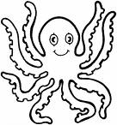 | 3 5 4
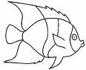 | 6 7 9
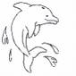 | 5 6 4
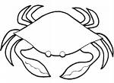 | 9 8 10
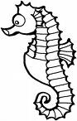 | 4 7 3

There are 5 octopuses. Count the sea creatures.
Are there more or less? Tick the right box.
more
less
more
less
more
less
more
less

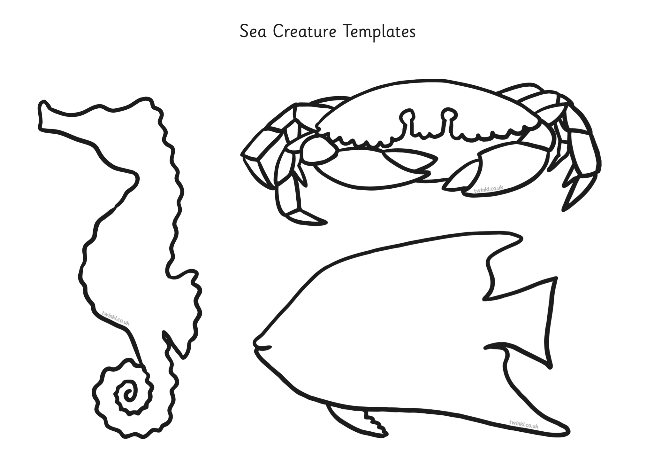
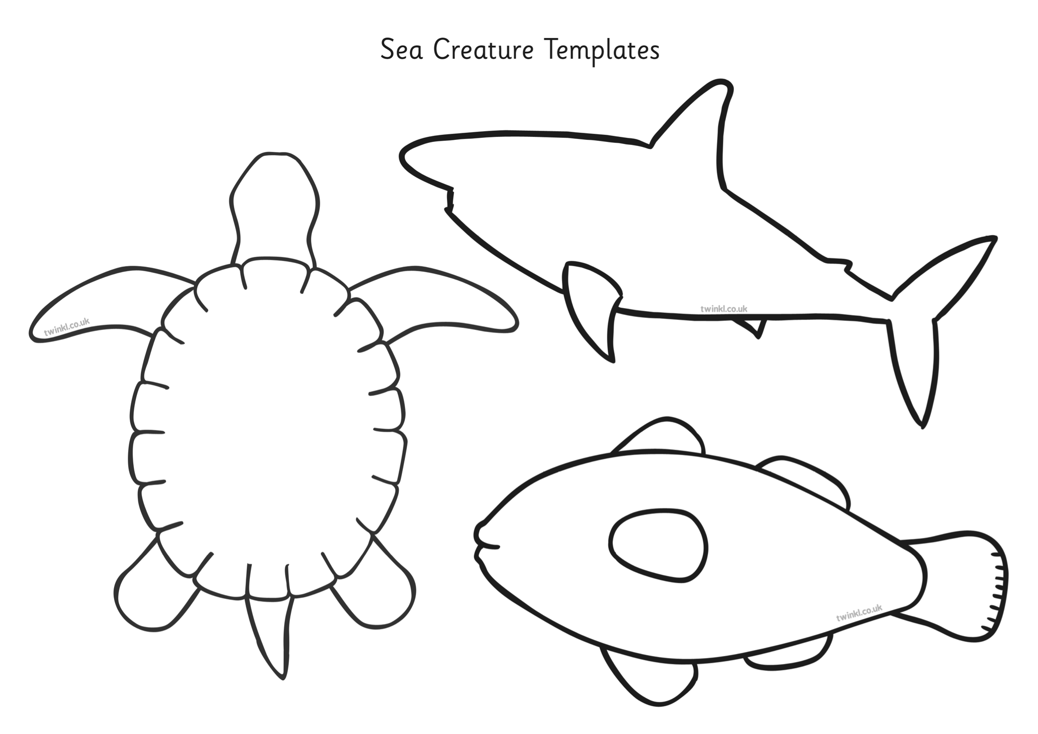
Decorate your manatee. You could use crayons, paint, glitter or tissue paper for a collage.
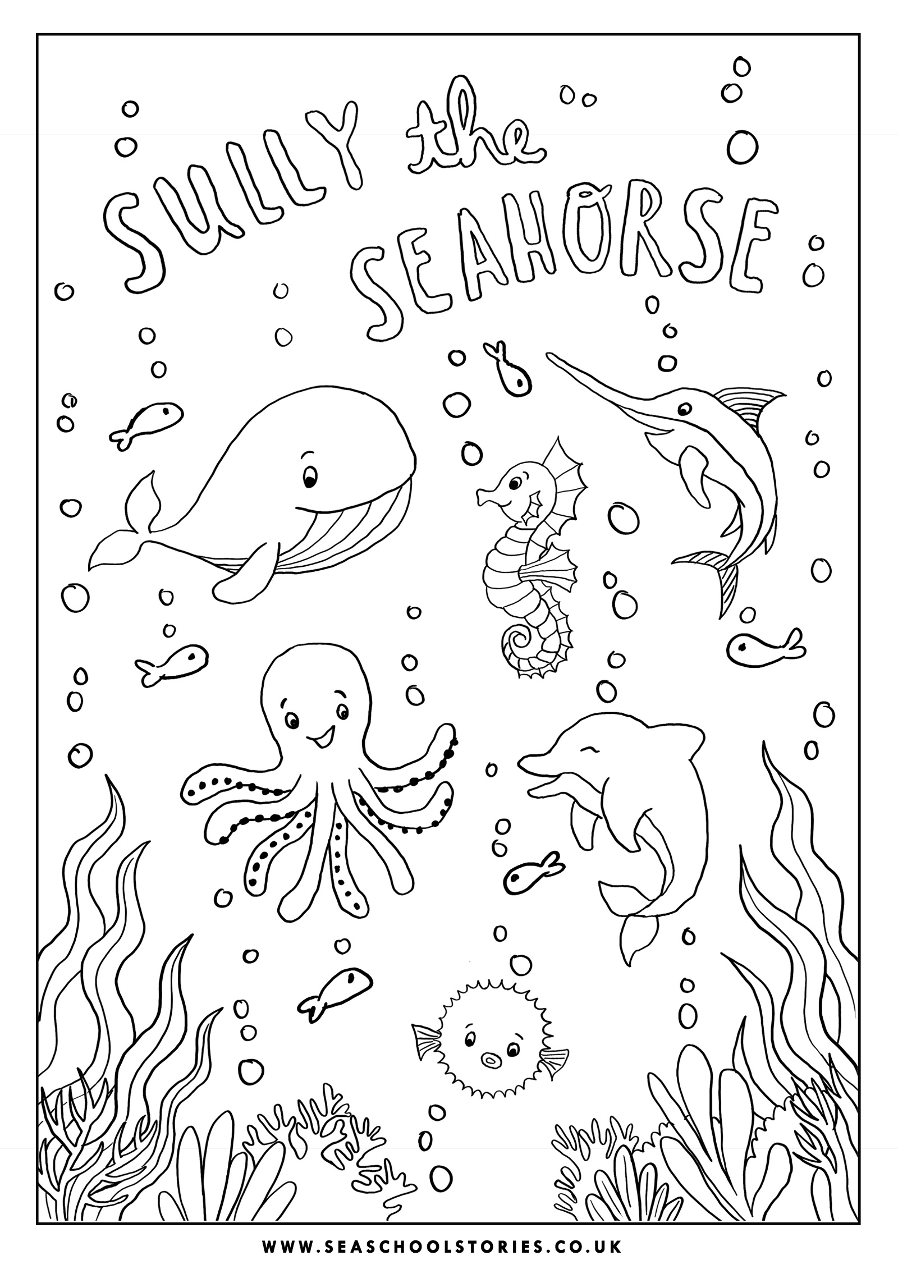
Sea Creature Craft Ideas
